From Available to Viable
Why AI Agent Governance Needs an Execution Layer
PV-PP Agent Governance White Paper v0.2
Productive Value-Productive Power (PV-PP) Framework

Core thesis
Tool availability is not execution viability. As AI agents move from answering questions to acting in real systems, governance must evaluate whether a proposed action is authorized, evidenced, constrained, recoverable, and operationally safe before execution.

Executive Summary
AI governance is moving into a new phase. The first wave centered on model behavior: prompts, hallucinations, training data, bias, privacy, and content safety. Those issues still matter, but autonomous and semi-autonomous agents create a different governance problem. They do not merely answer questions. They touch APIs, update records, route cases, draft or send communications, trigger workflows, classify exceptions, recommend approvals, and sometimes initiate or prepare financial actions.
Once an AI system can act, governance has to move closer to execution. A tool registry, permission layer, or model dashboard may show what an agent can call. It does not prove that the proposed action is viable. Viability depends on authority, evidence, constraints, recovery options, memory context, downstream risk, and the integrity of the execution path.
The Productive Value-Productive Power (PV-PP) Framework addresses this availability/viability gap. It treats action selection as a bounded governance problem rather than a single-score ranking problem. In routine cases, scalar scoring may be adequate. But when an action involves non-compensable constraints, conflicting domains, hidden authority, fragile recovery, or changing execution context, scalar scores can hide the very structure governance needs to preserve.
The PV-PP Agent Auditor is a practical first step. It is not a full runtime. It is an audit tool that surfaces whether a proposed agent workflow has unexamined execution authority, weak evidence, missing recovery paths, stale memory, unclear ownership, or downstream failure exposure. The long-term runtime pattern is a sidecar or execution gate: proceed, block, escalate, reframe, or recover based on viability, not mere availability.

The availability/viability distinction
Availability question | Viability question | Governance decision
Can the agent call this tool? | Is the action authorized for this actor, case, and context? | Proceed only if authority is clear.
Can the agent generate a recommendation? | Is the evidence adequate and current enough to support action? | Escalate or reframe if evidence is weak.
Can the workflow mark a task complete? | Would completion create an operational fact that hides unresolved risk? | Block or require human confirmation.
Can the system optimize for speed? | Does speed trade off against recovery, auditability, or downstream integrity? | Prefer bounded execution over raw throughput.

1. The Shift from Model Behavior to Execution Authority
Most AI governance discussions begin at the model layer. That is understandable: model behavior is visible, measurable, and familiar. Organizations can test prompts, monitor outputs, reduce hallucinations, control data exposure, and create review workflows around generated text.
Agentic systems change the center of gravity. A chatbot can be wrong and still be contained. An agent that updates a system of record, marks a transaction ready, sends an instruction, modifies a customer case, or routes an exception can create an operational fact. The risk is no longer limited to a bad answer. The risk is that an action becomes part of the organization’s execution fabric before anyone has established that the action was viable.
This is the execution-authority problem. The agent may have a technical route to act, but the organization may not have made explicit who owns that action, what evidence supports it, which constraints govern it, and what recovery path exists if it is wrong.

2. The Availability/Viability Gap
Availability means an action is technically reachable. A tool exists. An API call is permitted. A workflow endpoint is exposed. A model can produce an instruction or classification. Availability is necessary for action, but it is not governance.
Viability means the action remains structurally admissible under the current domain state. It asks whether the action is authorized, evidenced, constrained, recoverable, and safe in context. An available action can still be non-viable if it exceeds the user’s authority, relies on stale evidence, collapses an unresolved exception, violates a domain constraint, or creates a downstream integrity problem.
The gap is easiest to see in enterprise workflows. An agent may not have formal authority to release funds, but if it can mark a wire transfer as “ready for release,” its practical authority may be larger than its formal authority. It may not approve reimbursement, but if it extracts receipts, drafts business purpose language, and routes a package as complete, it can shape the decision path. The governance question is not simply whether the tool is available. It is whether the proposed action is viable.
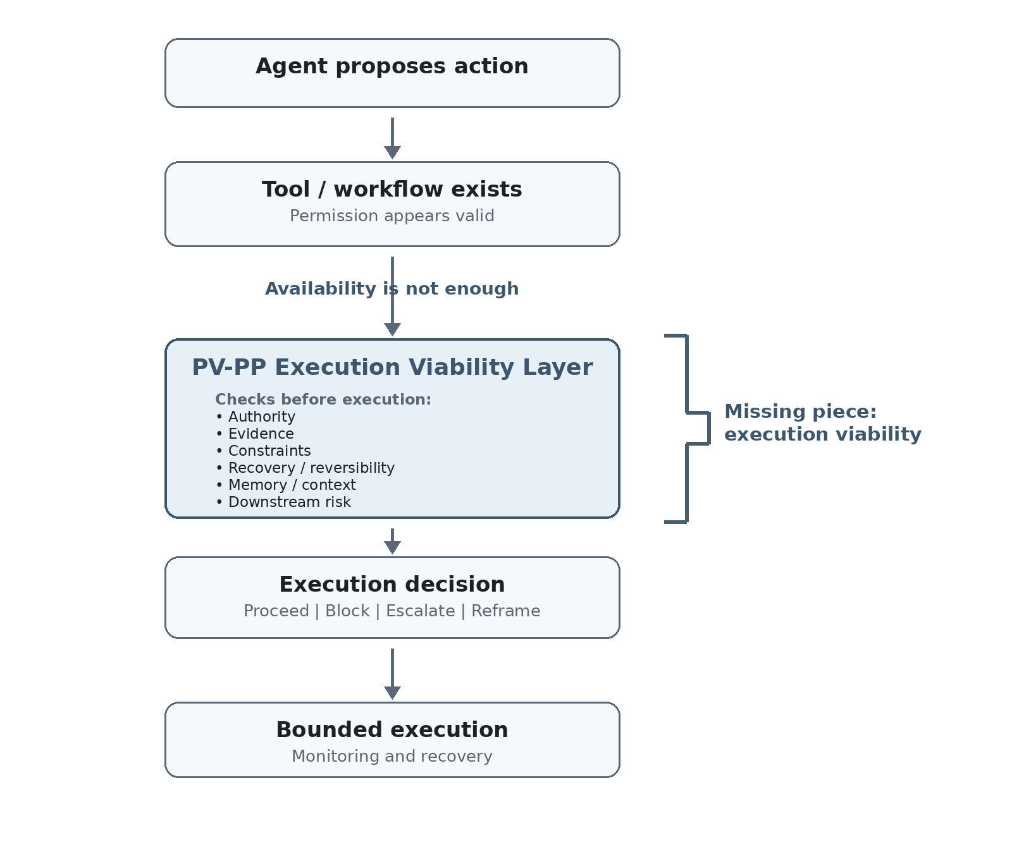
Figure 1. Tool availability does not determine execution viability. The missing governance layer is the viability check between permission and execution.

3. Why Permissions and Scalar Scores Are Not Enough
Permission systems answer a narrow question: is this actor allowed to access this capability? They do not fully answer whether this specific action is appropriate under this evidence state, recovery state, domain state, and operational context.
Scalar scoring has a parallel limitation. A single risk score, confidence score, priority score, reward score, or utility score can be useful when the relevant concerns are safely substitutable. In routine cases, an organization may reasonably trade speed, cost, confidence, and convenience inside a single ranking function.
The problem appears when the domains are not safely substitutable. A high confidence score should not compensate for missing authority. Operational speed should not compensate for missing evidence. A strong local optimization should not compensate for a downstream integrity failure. In these cases, scalar scoring can compress the wrong things together. It can make an action look optimal because the score improved, while the action remains non-viable.

4. The PV-PP Framework in Plain English
The Productive Value-Productive Power (PV-PP) Framework begins from a simple distinction. Productive Value is the value, information, support, or effect exchanged through action. Productive Power is the accumulated capacity that allows a person, system, institution, or agent to keep acting. An action can generate local value while degrading the capacity needed to act safely later.
The framework also separates actual productive power from perceived productive power. An agent or human system acts through what it can represent, retrieve, and evaluate. If the system’s perceived state is distorted, stale, incomplete, or overconfident, its action selection can become non-viable even when better actions exist in reality.
PV-PP governance does not treat every domain as commensurable. Some domains become governing because collapse or breach in that domain cannot be repaired by surplus elsewhere. In an agent setting, governing domains may include authority, evidence adequacy, regulatory constraint, privacy, financial integrity, reversibility, operational continuity, or user harm.

5. What the PV-PP Agent Auditor Checks
The PV-PP Agent Auditor operationalizes the framework as a structured review. It asks what the agent is supposed to do, who is affected, what tools and permissions it has, what information it relies on, what decisions it makes, what failure would cost, how feedback and correction work, and where the weak points may be.
The output is not a generic risk score. It is a structured map of hidden execution authority, evidence gaps, permission ambiguity, memory/retrieval risk, downstream exposure, false-success signals, and recovery weakness. That distinction matters. A governance audit should not merely say that a workflow is high or low risk. It should identify where the action path becomes non-viable and why.
This makes the Auditor a practical front door. It can be used before a full runtime exists, before policies are fully formalized, and before agent workflows are deployed at scale. It helps teams see the execution problem earlier.

6. Example: The “Ready for Release” Failure Mode
Consider an agent used to support financial operations. The organization says the agent cannot approve or release funds. Formally, the control looks safe. But the agent can collect records, interpret exceptions, classify missing information, and mark a transaction as “ready for release.”
Under time pressure, “ready for release” can become practical approval. The agent did not press the final button, but it shaped the execution state that made the final button likely. The governance failure is not merely model hallucination. It is hidden authority. The agent’s practical role exceeded the organization’s explicit delegation.
A PV-PP audit would ask whether the evidence is adequate, whether the agent has practical authority beyond formal permission, whether the downstream approver receives enough uncertainty information, whether the action is reversible, and whether the workflow rewards false readiness. The central question is not whether the agent can prepare the transaction. It is whether that preparation is viable under the governing domains of authority, evidence, financial integrity, and recovery.

7. A Runtime Governance Pattern
The natural runtime pattern is an execution viability layer between tool availability and action. The agent proposes an action. The governance layer evaluates the action before execution. The result is not a score. It is an execution decision: proceed, block, escalate, reframe, or recover.
A minimal version can begin as a pre-execution check for high-risk tool calls. The action payload includes the proposed tool, target object, actor, evidence source, authority basis, and expected downstream effect. The viability layer evaluates whether the proposed action is admissible before it becomes an operational fact.
A mature version can add typed memory, domain-state tracking, evidence freshness, authority models, and execution monitoring. But the adoption path should be staged. PV-PP should not be presented as a requirement to run every trivial action through a heavy framework. It should begin where agent execution risk is material.

8. What Organizations Should Do Now
First, inventory where agents or automations create operational facts. Look beyond formal approval buttons. Include status changes, routing decisions, exception classifications, completed-task markers, draft communications, record updates, and recommendations that humans routinely accept.
Second, separate availability from viability. For each high-risk action, define what authority, evidence, constraint, recovery, memory, and downstream-risk conditions must hold before execution is allowed.
Third, identify false-success metrics. An agent that closes cases quickly, marks tasks complete, or reduces manual review may appear successful while increasing downstream exposure. Governance has to preserve recovery and integrity, not just throughput.
Fourth, start with an audit layer before attempting a full runtime. The fastest practical step is to make execution authority visible. Once the action boundaries are visible, runtime controls can be staged around the highest-risk points.
The PV-PP Agent Auditor is available as a structured starting point for that review. It asks a compact set of questions about purpose, users, tools, permissions, source quality, decision authority, failure impact, oversight, and recovery paths. The goal is not to certify that an agent is safe. The goal is to make hidden governance assumptions visible before they become operational facts.

9. Limits and Next Steps
The PV-PP approach has implementation overhead. It requires domain definitions, authority models, evidence standards, and recovery rules. That overhead is not justified for every low-risk action. Scalar routing and ordinary permission controls will remain adequate in many routine cases.
The claim is narrower and stronger: scalar scoring and tool availability are not sufficient as general foundations for agent execution governance. They are useful inside safe regimes. They become dangerous when they hide governing constraints, non-substitutable risks, or changing execution context.
The next step is to connect the audit layer to runtime gates. The practical goal is not to replace every agent architecture. It is to add a viability layer where execution authority becomes operationally material.
Governance does not slow agentic systems. It prevents execution authority from becoming invisible.

Appendix: Compact PV-PP Vocabulary
Term | Plain-English meaning
Productive Value (PV) | The value, information, support, or effect exchanged through action.
Productive Power (PP) | The accumulated capacity that allows a system to keep acting and recovering.
Perceived Productive Power (PPP) | The system’s represented or believed capacity, which may diverge from actual PP.
Governing domain | A domain where breach or collapse cannot safely be compensated by surplus elsewhere.
Adequacy | A check that a candidate action has enough evidence, authority, context, and fit to remain viable.
Sigma (Σ) | The selection stage that preserves governing-domain non-domination before any downstream refinement.
Execution epsilon (ε) | The bounded execution interval where selected action can still fail, drift, or require recovery.
Viability | A proposed action’s admissibility under authority, evidence, constraint, recovery, memory, and downstream-risk conditions.

